**Course**: Probability, Statistics and Machine  
Learning– ENDG 319  
**Deliverable #**: 1  
**Student Name**: Gerard Ledoux Mendjemo Ngangom  
**Lecture Section**: L01  
**Date submitted**: Sept 29, 2023

Task 1

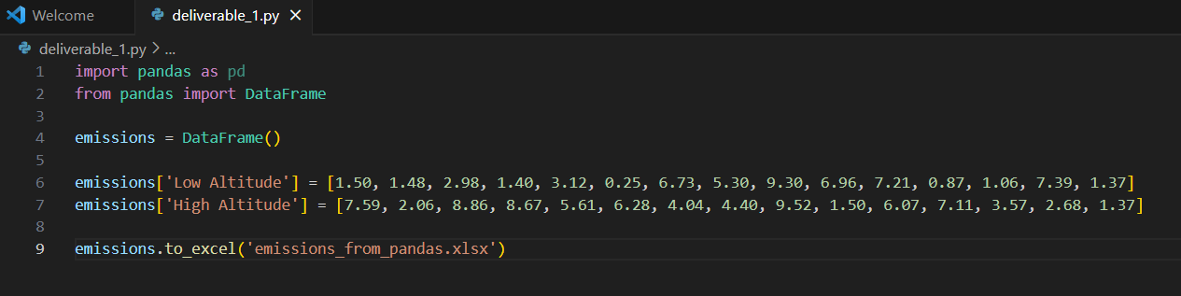

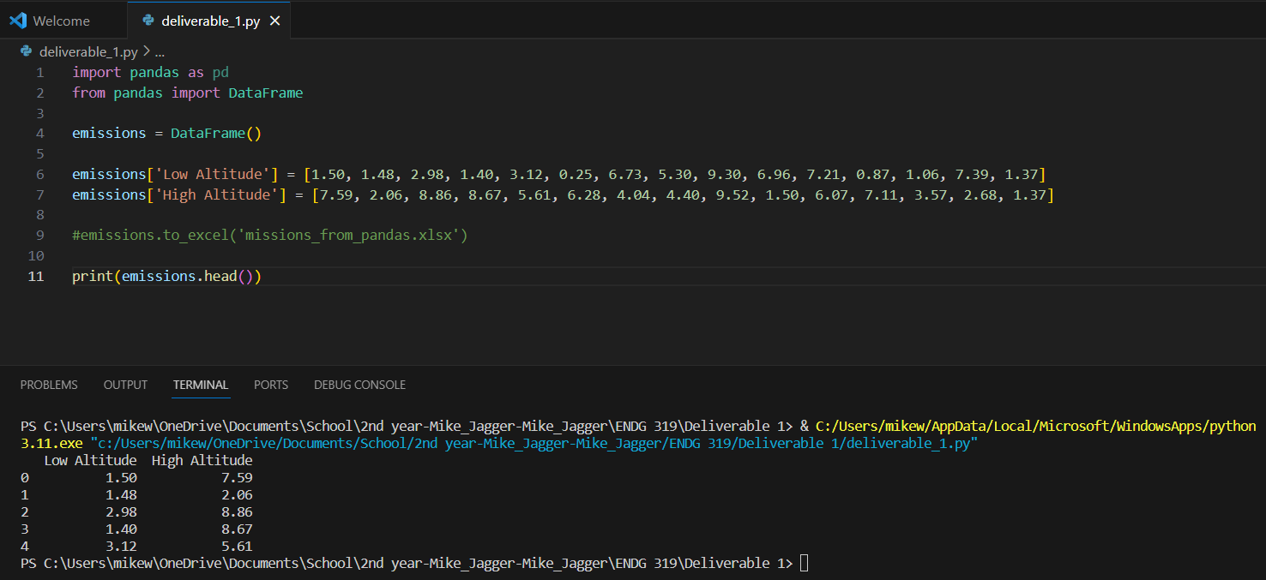

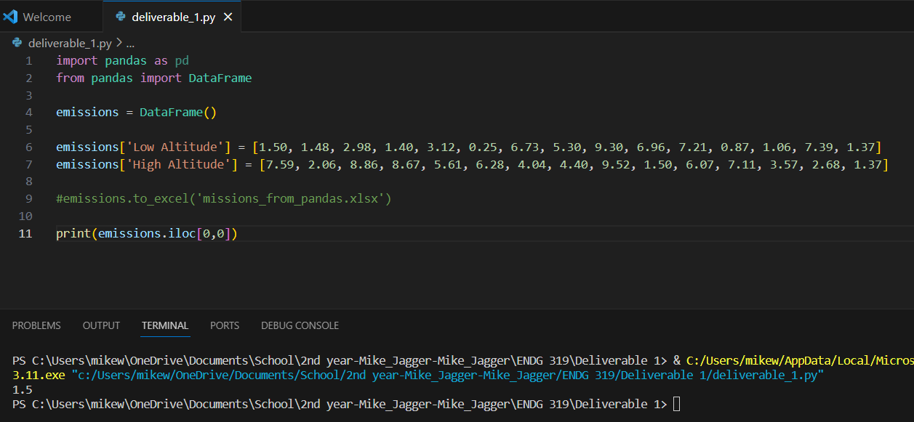

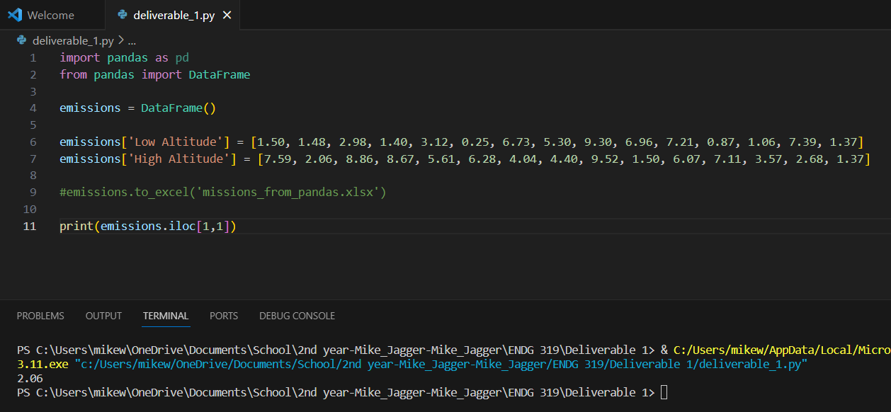

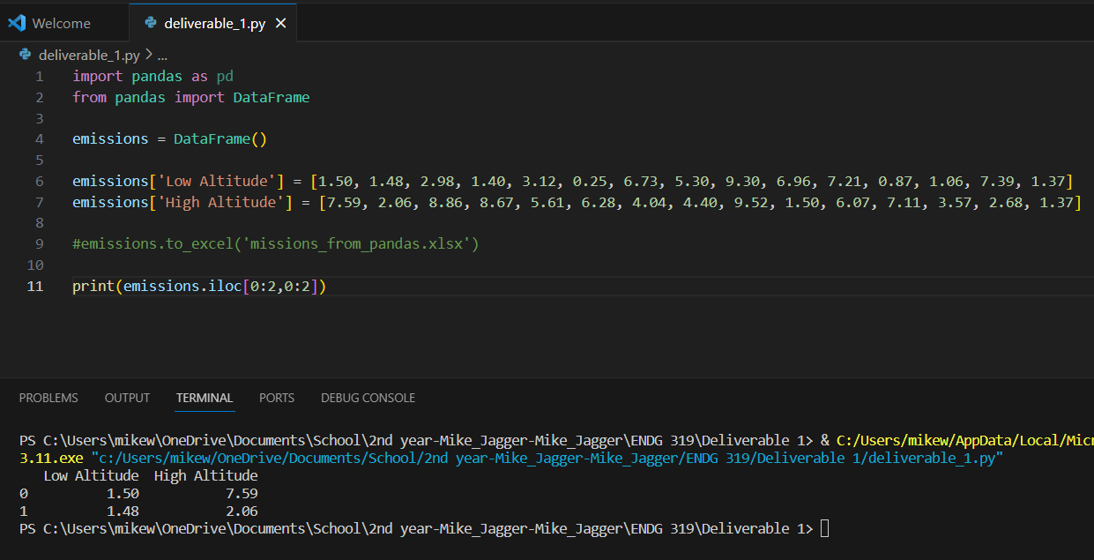

Task 2

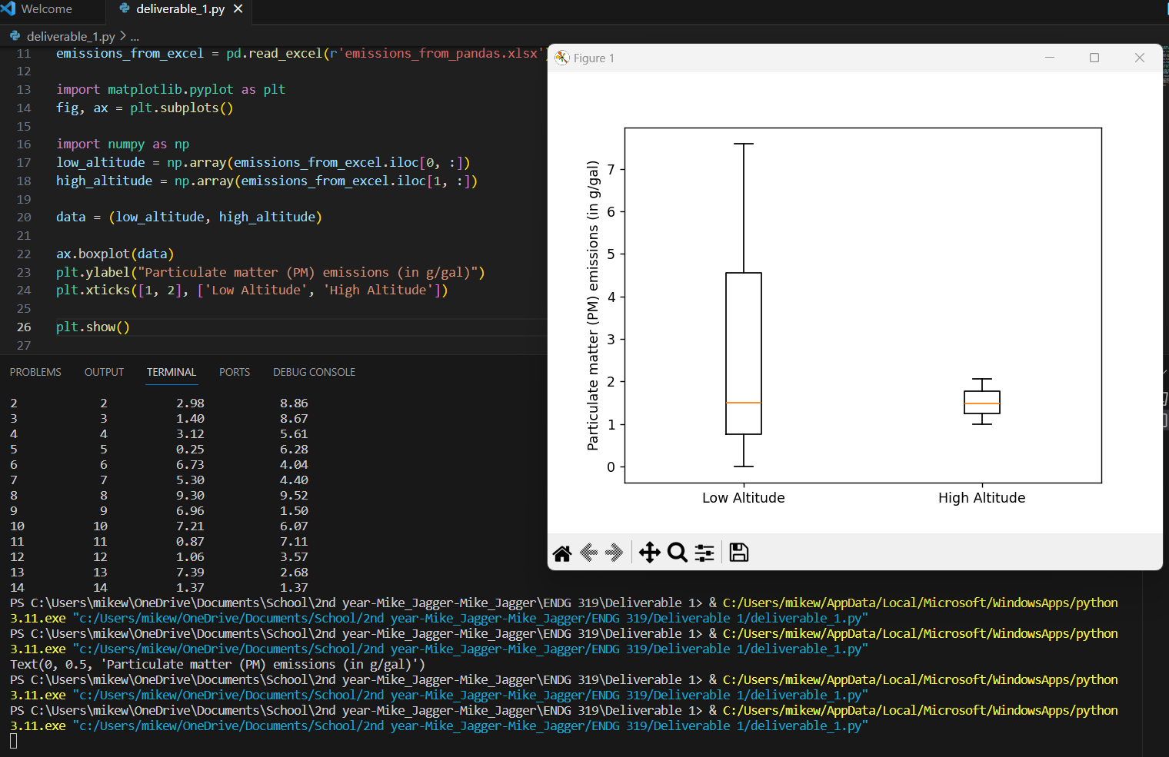

In a boxplot with sample values, the box represents the middle 50% of the data, where the lower edge is the 25th percentile (Q1) and the upper edge is the 75th percentile (Q3). The line inside the box is the median (50th percentile). The whiskers extend to the minimum and maximum values within 1.5 times the IQR (IQR = Q3 - Q1).

1. a.

b.

Task 3

a) and b)

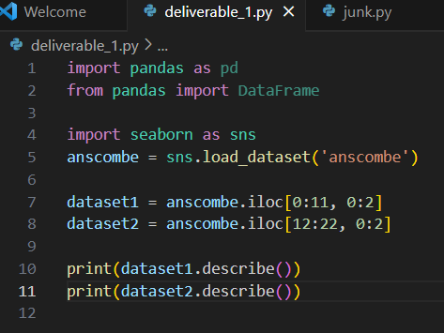

c) Yes. There is the difference between the count, mean, standard deviation, 25th, 50th and 75th percentile of both datasets

d) Dataset1

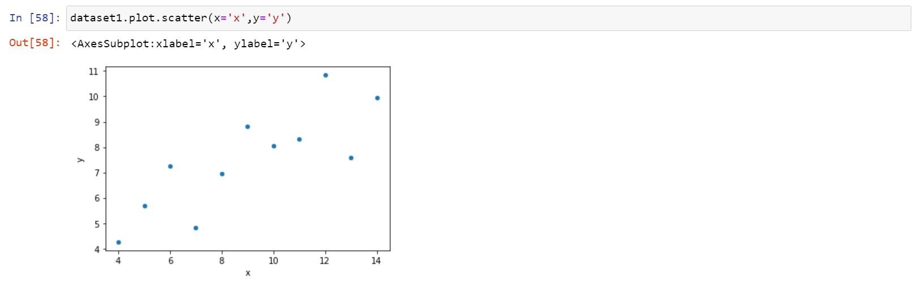

Dataset2

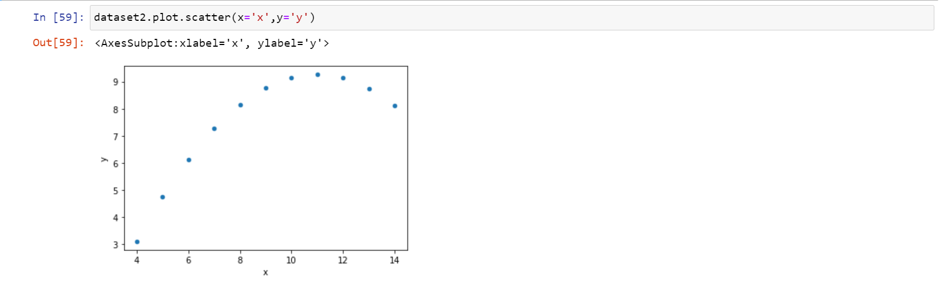

The points of the plot of dataset1 are scattered across the graph. However, that of dataset2 come together to form a quadratic-like graph.

TASK 4

a)

b)

